## Task 2: Permissions and Scripting

* Create a new file called "my_script.sh".
* Edit "my_script.sh" using a text editor of your choice and add the following lines:

# bash

**#!/bin/bash**

# echo "Welcome to my script!" echo "Today's date is $(date)." Save and exit the file.

* Make "my_script.sh" executable.
* Run "my_script.sh" and verify that the output matches the expected result.

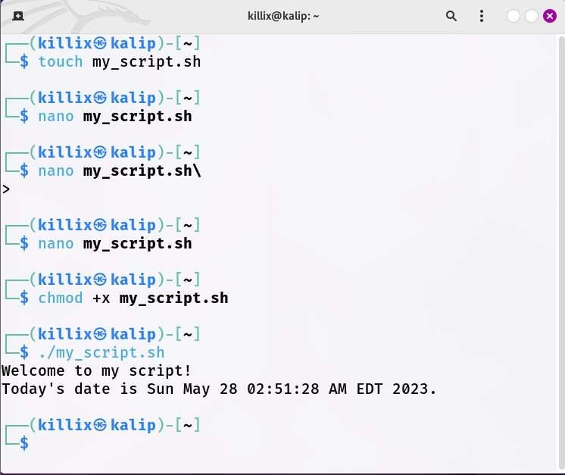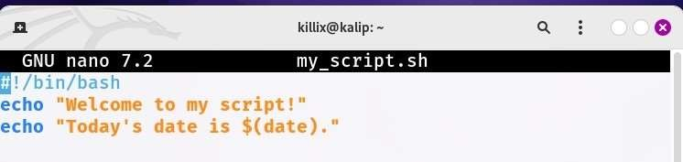

## Task 3: Command Execution and Pipelines

* List all the processes running on your system using the "ps" command.
* Use the "grep" command to filter the processes list and display only the processes with "bash" in their name.
* Use the "wc" command to count the number of lines in the filtered output.

